General 12 Human Biology Name __________________________

Microscope Assignment Verification (20 marks total)

- Label these parts of a microscope. (3 marks)

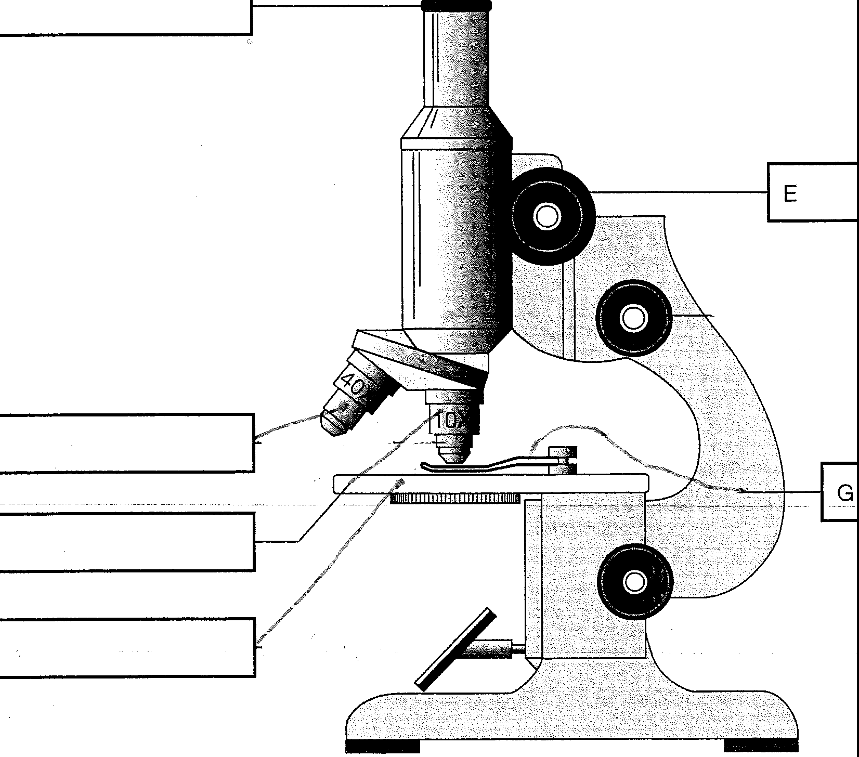

A

B

C

D

- If an eyepiece is xlO magnification and the objective lens is a xlO magnification, what is the overall magnification of the microscope?

(1 mark)

- When the eyepiece is xlO and the objective is at x4 magnification the field of view is 2 mm. What is the field of view in micrometres?

(1 mark) Using this microscope magnification, how wide is the cell in this diagram? _________________________

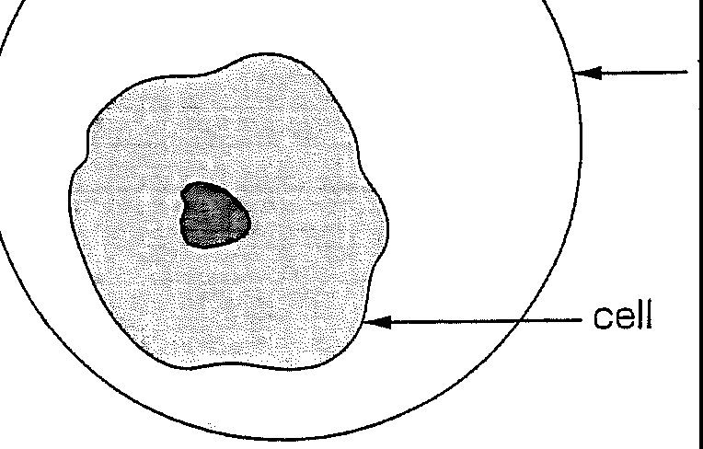
field of view

X40 (1 mark)

- To change to high power the student from the previous question changes the objective lens to a x40 and keeps the eyepiece at xlO.
What is the new magnification under high power?

(1 mark)

What is the new field of view under high power?

(1 mark)

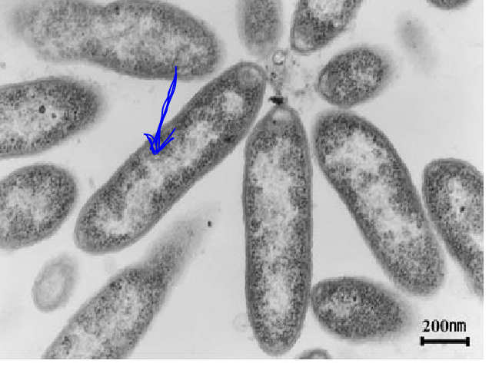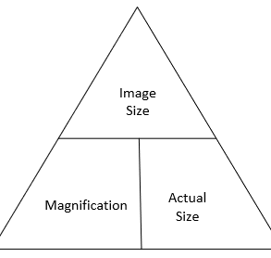
- Using the image above, calculate the actual size (length) of the bacterium indicated by the arrow in mm. Remember: 1mm = 1,000,000 nm. Show your working. (2 marks)

In Class Teacher Observations

Student has demonstrated
  - They can focus on low power.

(1 mark)

  - They can refocus on high power.

  - Drawn/Labelled prepared slide.

  - Made a wet mount slide.

  - Drawn/labelled a stained slide.
(1 mark) (3marks) (2marks) (3marks)

